Retinal Disease Classification
Objective:
The objective of this study is to develop an intelligent framework that integrates retinal disease classification with digital twin technology to enable personalized and predictive eye care.
Retinal diseases such as Dry AMD (Age-Related Macular Degeneration), Glaucoma, Normal Fundus, Wet AMD, Mild Diabetic Retinopathy, Moderate Diabetic Retinopathy, Severe Diabetic Retinopathy, Proliferate Diabetic Retinopathy, Cataract, Hypertensive Retinopathy, Pathological Myopia are leading causes of vision loss.

Literary Review:
For this project, we selected the Retinal Fundus Images dataset because it offers a diverse collection of high-resolution images across 11 distinct categories of retinal diseases.

Early and accurate detection of retinal conditions like Diabetic Retinopathy, AMD, and Glaucoma is crucial in preventing irreversible vision loss, yet manual diagnosis is time-consuming and prone to human error.

This dataset provides an ideal foundation for developing automated deep learning models that can assist ophthalmologists by speeding up diagnosis, improving accuracy, and enabling scalable screening solutions.

Besides the Retinal Fundus Images dataset, several other well-known datasets focus on retinal disease detection and medical image analysis.

The EyePACS dataset is widely used for Diabetic Retinopathy classification and contains tens of thousands of labeled fundus images with varying disease severity levels.

The MESSIDOR dataset is another popular choice, designed specifically for diabetic retinopathy research, providing high-quality images along with clinical grades.

There’s also the DRIVE dataset, which focuses on vessel segmentation tasks, helping analyze the structure of blood vessels in the retina.

Data Exploration:
The dataset contains images of both the left and right eyes from patients, covering 11 distinct disease categories, including Dry AMD, Wet AMD, Mild DR, Moderate DR, Severe DR, Proliferative DR, Central Serous Retinopathy, Hypertensive Retinopathy, Myopia, Other retinal diseases, and Normal Fundus. Each disease category is represented by its own folder, and within these, images are organized without explicit separation of left and right eyes, meaning both types are mixed throughout the dataset.

The images were collected from real clinical settings and vary significantly in terms of resolution, lighting conditions, and pathological features, providing a challenging yet realistic dataset for training automated retinal disease classifiers.

The dataset is divided into three main subsets: training, validation, and testing, allowing for proper model development and evaluation. This setup reflects real-world use cases where models need to generalize across diverse eye conditions and image qualities.

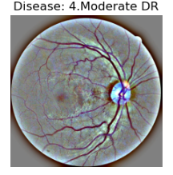
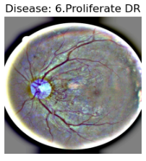
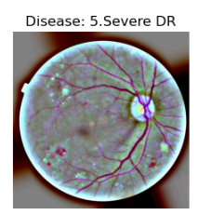
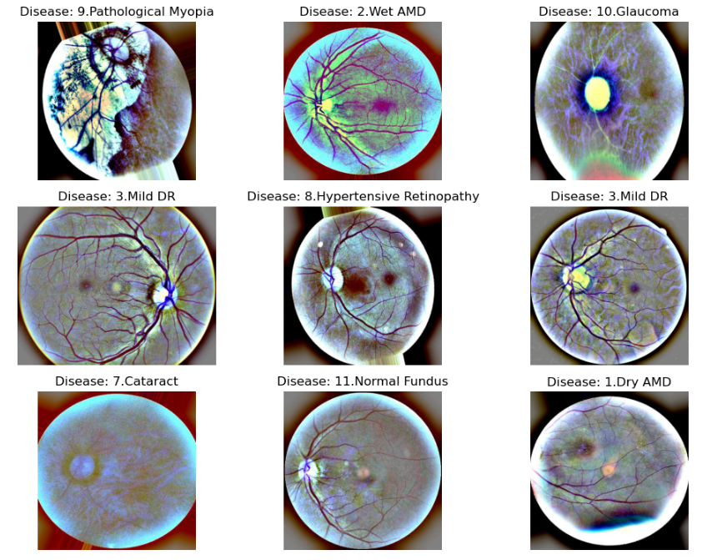

Class Distribution of Retinal Fundus Dataset:

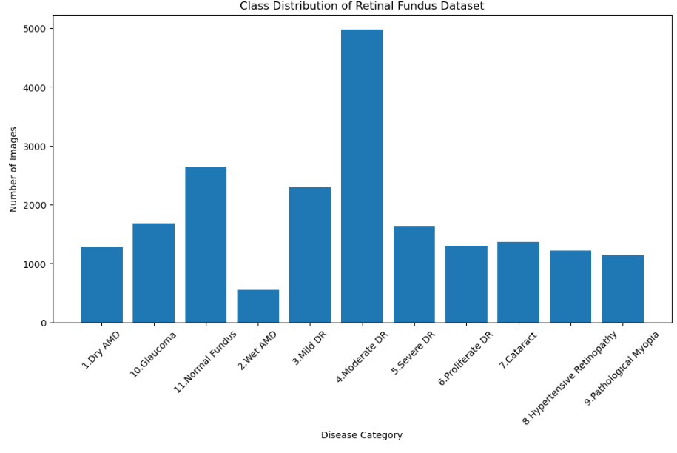

Data Preprocessing:
To standardize the dataset, all images were resized to a fixed dimension of 224×224 pixels. This approach ensures consistency across the dataset while preserving the overall content of each image. Depending on the scenario, other techniques such as center cropping or padding can also be used to maintain the aspect ratio without distortion.

Finding number of uneven sized images:
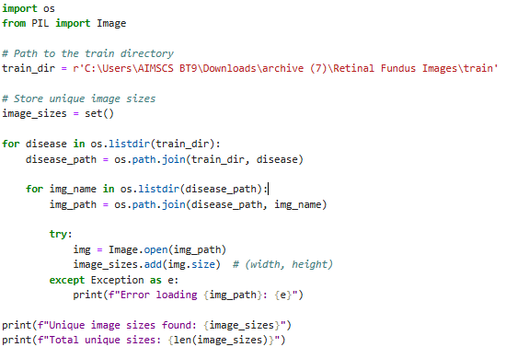
This code finds different sizes of the images in the dataset.
We found 236 images which were of different or uneven size.
Resizing all images to a common size:
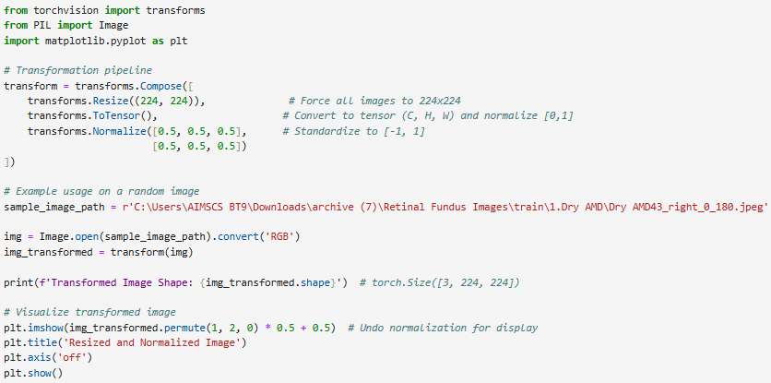
This code resizes all the images to a common size i.e 224*244 pixels
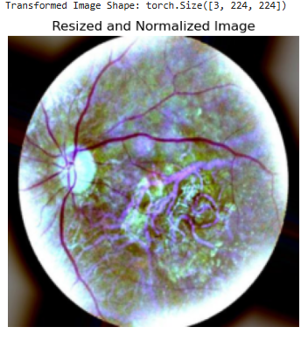

Resizing images before model building and training will allow a comprehensive input for the feature selection.

